MTH4600

HW1 – Results of the code

2/12/2019

1. Test with Multiply-With-Carry (MWC) RNG
2. result with n = 10 million

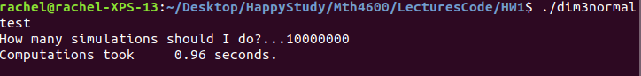

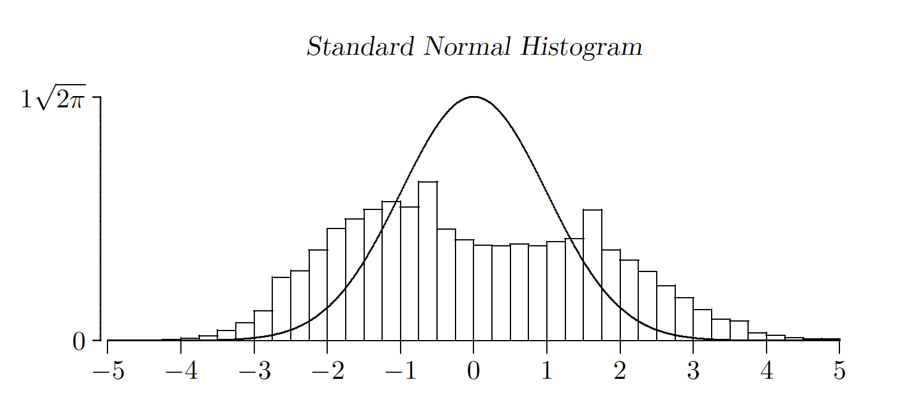

1. when n = 50million

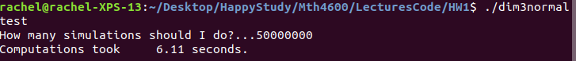

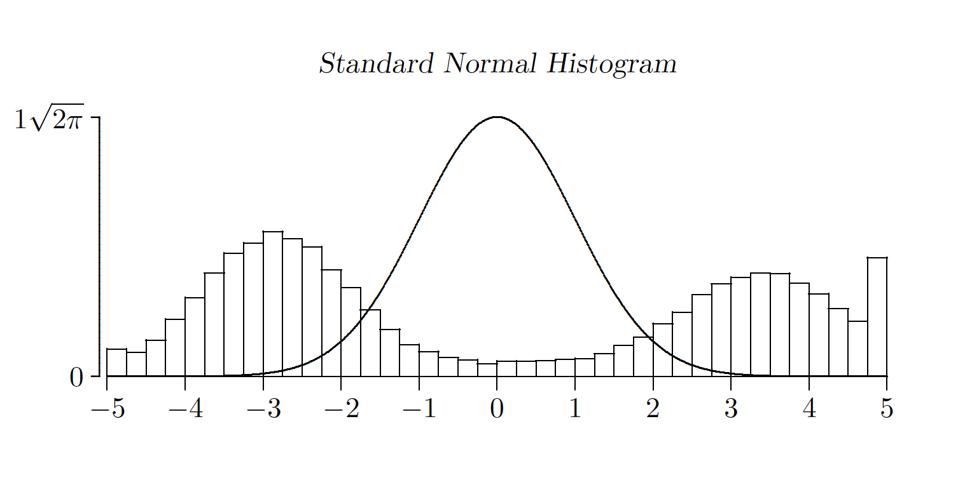

1. when n = 100 millon

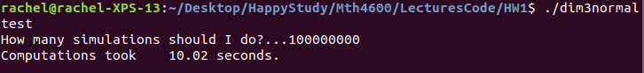

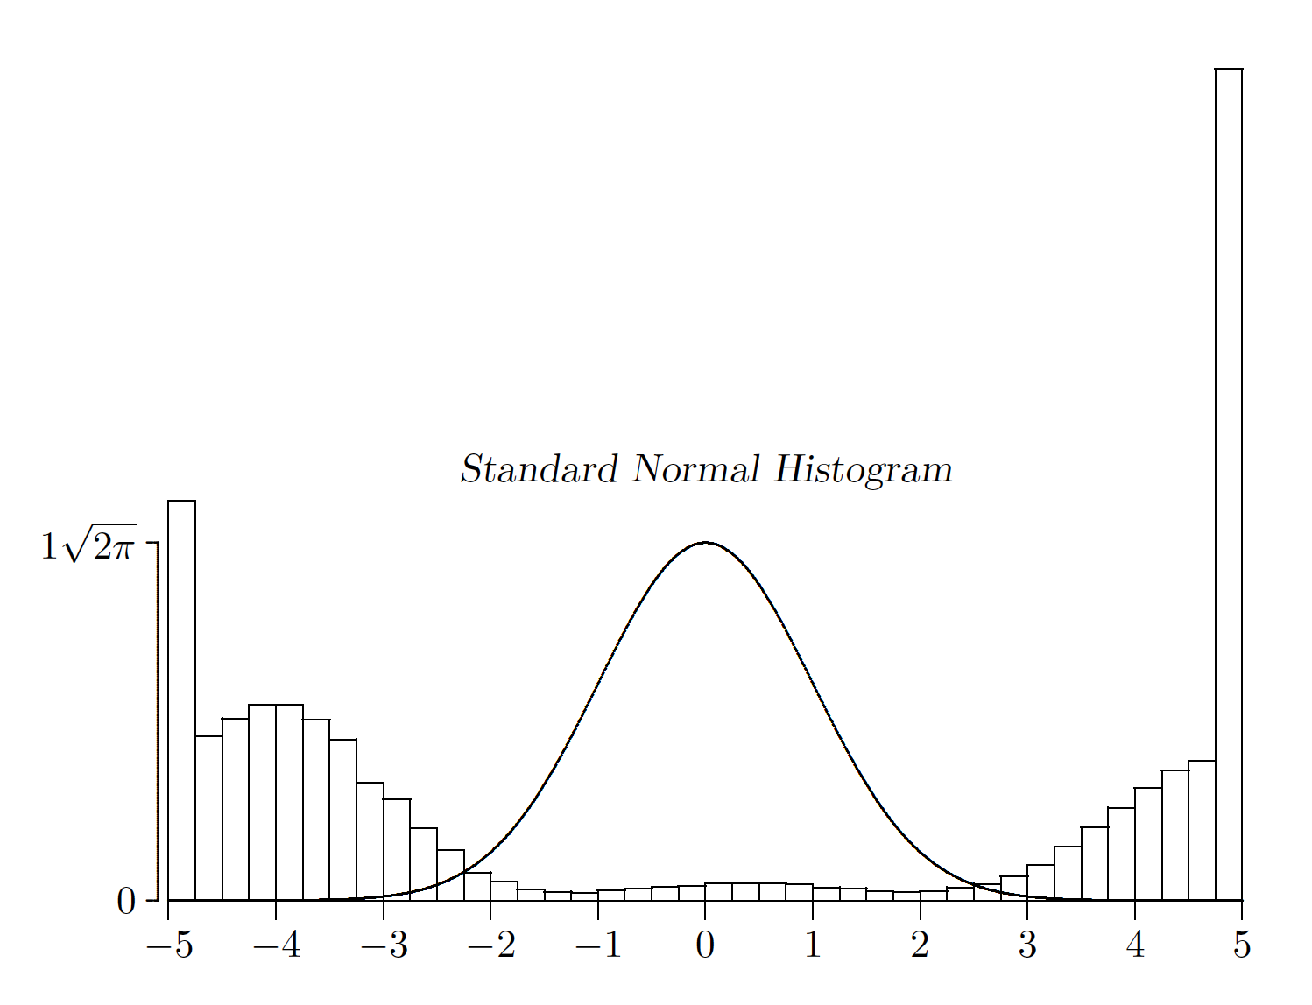

Thus, the MWC does not pass the test.

1. Test with Mersenne Twister (MT) as RNG
2. When n = 10 million

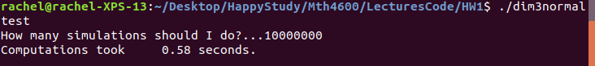

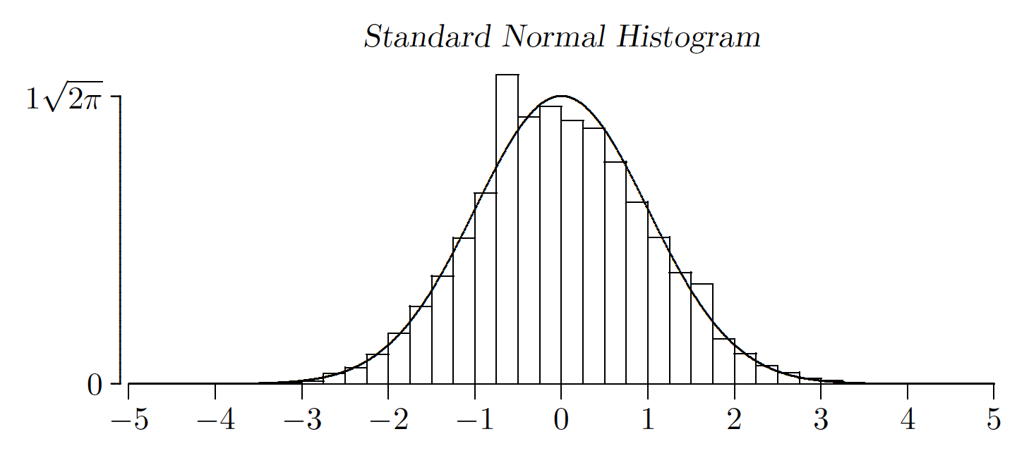

1. When n = 50 million

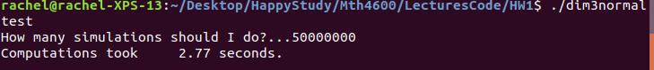

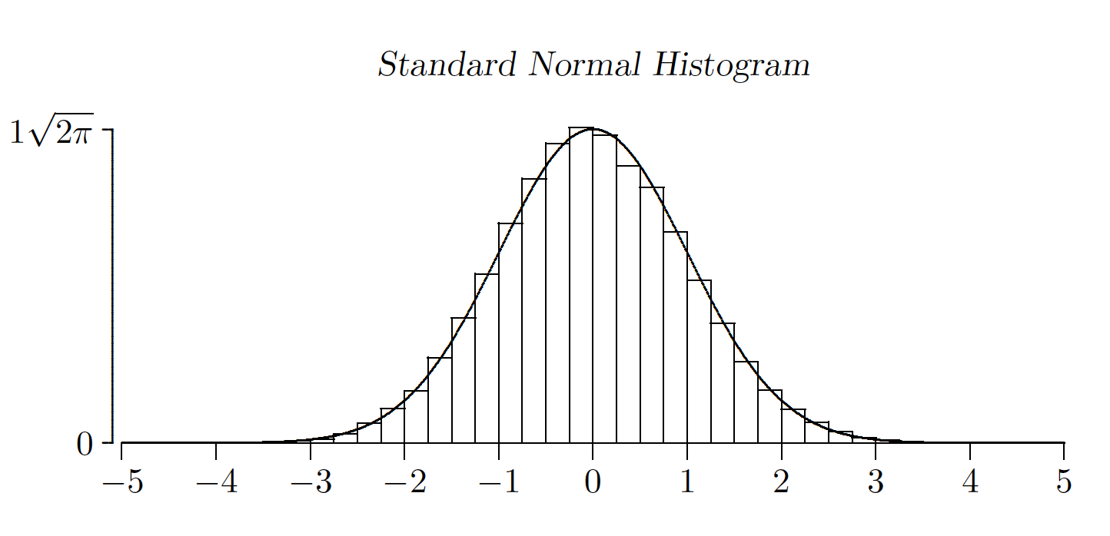

1. When n = 100 million

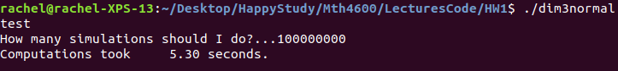

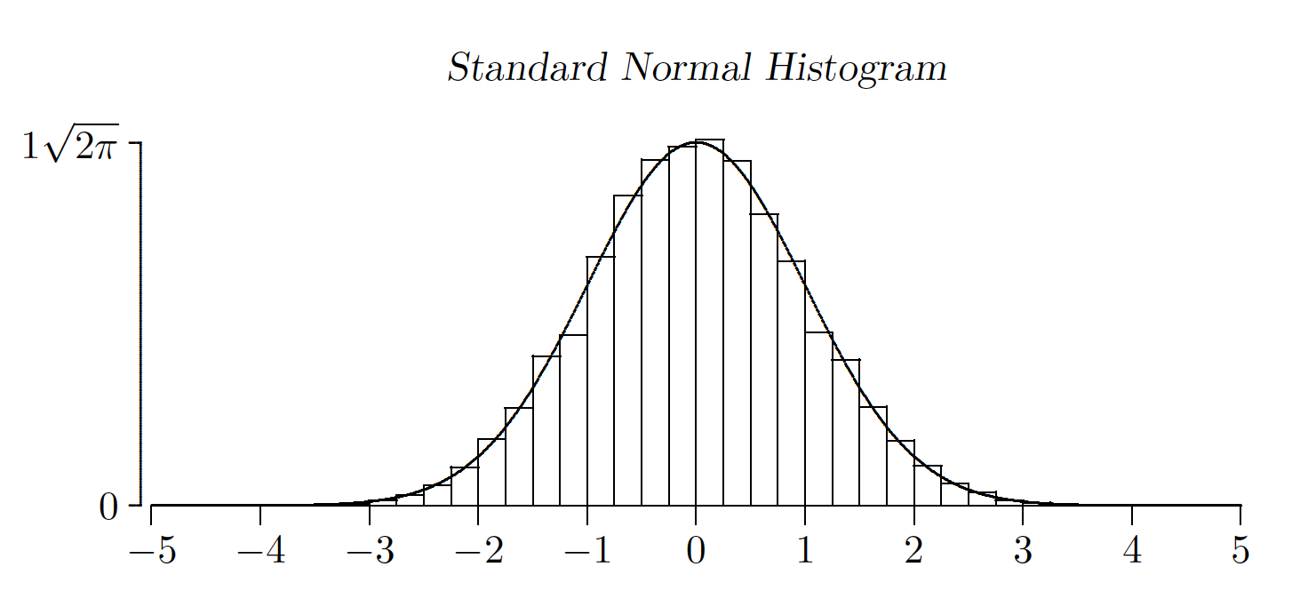

Thus, as we can see from the graphical output, MT passes the test, and

U ~ Uniform {(x, y, z) : 0 < x < 1, 0 < y < 1, 0 < z < 1} holds.